v

SIMATS ENGINEERING Vishal kruthik
192521179

ASSESSMENT TOOL 3

COURSE NAME: Database Management Systems COURSE CODE: CSA05

COURSE OUTCOME COVERED

CO3: Analyze relational databases using functional dependencies, normalization (1NF to 5NF), and key constraints to identify redundancy and ensure data integrity. (BL2, BL3)

Activity Tool : MCQ Test (Low) Assessment Tool Weightage: 30%

QUESTIONS Total Marks: 50
Q.No | Question | Bloom's Level | Marks
1 | Which of the following is true about 1NF? (a) Allows multi-valued attributes (b) Eliminates partial dependencies (c) All attributes must be atomic (d) Eliminates transitive dependencies | BL2 – Understand | 5
2 | A relation is in 2NF if it is in 1NF and: (a) Has no transitive dependencies (b) Has no partial dependencies on primary key (c) Every attribute is a prime attribute (d) Has no multi-valued dependencies | BL2 – Understand | 5
3 | Which normal form deals with multi-valued dependencies? (a) 2NF  (b) 3NF (c) BCNF (d) 4NF | BL2 – Understand | 5
4 | BCNF is a stricter version of: (a) 1NF (b) 2NF (c) 3NF (d) 4NF | BL2 – Understand | 5
5 | Functional dependency X → Y means: (a) Y determines X (b) X determines Y (c) X and Y are unrelated (d) Both determine each other | BL2 – Understand | 5
6 | Which of the following anomaly is NOT associated with unnormalized relations? (a) Insertion anomaly (b) Deletion anomaly  (c) Update anomaly (d) Retrieval anomaly | BL2 – Understand | 5
7 | A superkey is: (a) A minimal set of attributes that uniquely identifies tuples (b) Any set of attributes that uniquely identifies tuples (c) An attribute that depends on a non-prime attribute (d) A foreign key reference | BL2 – Understand | 5

8 | If R(A,B,C) has FD: A→B and B→C, then C is: (a) Partially dependent on A (b) Fully dependent on A (c) Transitively dependent on A (d) Independently determined | BL2 – Understand | 5
9 | 5NF is also known as: (a) Domain-Key Normal Form (b) Boyce-Codd Normal Form (c) Project-Join Normal Form (d) Element  Normal Form | BL2 – Understand | 5
10 | Lossless-join decomposition ensures: (a) No data is lost during decomposition (b) All FDs are preserved (c) The relation is in BCNF  (d) No null values exist | BL2 – Understand | 5

Code of Conduct:

I Vishal Kruthik (192521179) certify that this submission is my original work and that I have adhered to the guidelines specified for this assessment.
I understand that any violation of academic integrity rules will result in disciplinary action.

Signature of the student:


RUBRICS FOR CALCULATION:

MCQ
Criteria | Weightage (%) | Level 4 (Exemplary) | Level 3 (Proficient) | Level 2 (Developing) | Level 1 (Beginning)
Conceptu al Understa nding | 30% | Demonstrates thorough understanding; answers all questions accurately | Shows good understanding with few errors | Partial understanding; several incorrect responses | Lacks understanding; majority of answers incorrect
Accuracy of Answers | 25% | All answers are correct | Most answers are correct with minor mistakes | Some correct answers; frequent errors | Mostly incorrect answers
Applicatio n of Knowledg e | 20% | Correctly applies concepts to problem-based questions | Applies concepts with minor errors | Limited ability to apply concepts | Unable to apply concepts
Time Managem ent | 15% | Completes quiz well within time efficiently | Completes on time with minor delays | Requires extra time or rushes through questions | Unable to complete within given time
Question | 10% | Interprets all | Misinterprets a | Often | Unable to

Interpretat ion |  | questions correctly and responds appropriately | few questions | misinterprets questions | understand questions

Question 1
Which of the following is true about 1NF?
(a) Allows multi-valued attributes
(b) Eliminates partial dependencies
(c) All attributes must be atomic ✓ Correct Answer
(d) Eliminates transitive dependencies
Concept:
First Normal Form (1NF) is the most basic level of normalization. A relation is in 1NF if every attribute (column) contains only a single, indivisible (atomic) value for each row, and there are no repeating groups or arrays stored in one cell. If a column stores multiple values (like a comma-separated list of phone numbers), the table violates 1NF.
Diagram:
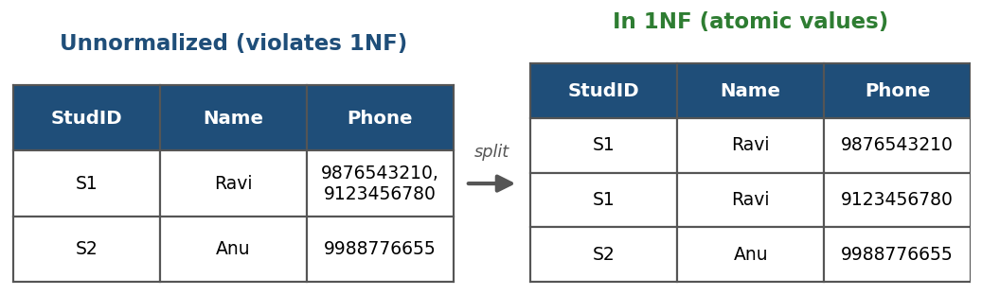
SQL Illustration:
-- Violates 1NF: Phone column stores multiple values
CREATE TABLE Student_Bad (
StudID VARCHAR(10),
Name VARCHAR(50),
Phone VARCHAR(100) -- '9876543210,9123456780'
);

-- Fixed to satisfy 1NF: one atomic phone value per row
CREATE TABLE Student_1NF (
StudID VARCHAR(10),
Name VARCHAR(50),
Phone VARCHAR(15),
PRIMARY KEY (StudID, Phone)
);
Explanation:
1NF requires that every attribute in a relation hold only a single, indivisible (atomic) value — no repeating groups or multi-valued attributes are allowed. Options (a), (b) and (d) describe properties of higher normal forms (2NF and 3NF), not 1NF.
Bloom's Level: BL2 – Understand Marks: 5

Question 2
A relation is in 2NF if it is in 1NF and:
(a) Has no transitive dependencies
(b) Has no partial dependencies on primary key ✓ Correct Answer
(c) Every attribute is a prime attribute
(d) Has no multi-valued dependencies
Concept:
Second Normal Form (2NF) applies to relations that have a COMPOSITE primary key (made of two or more attributes). A relation is in 2NF when it is already in 1NF and every non-key attribute depends on the WHOLE composite key, not just part of it. If an attribute depends on only part of the key, that is a partial dependency and it must be removed by splitting the table.
Diagram:
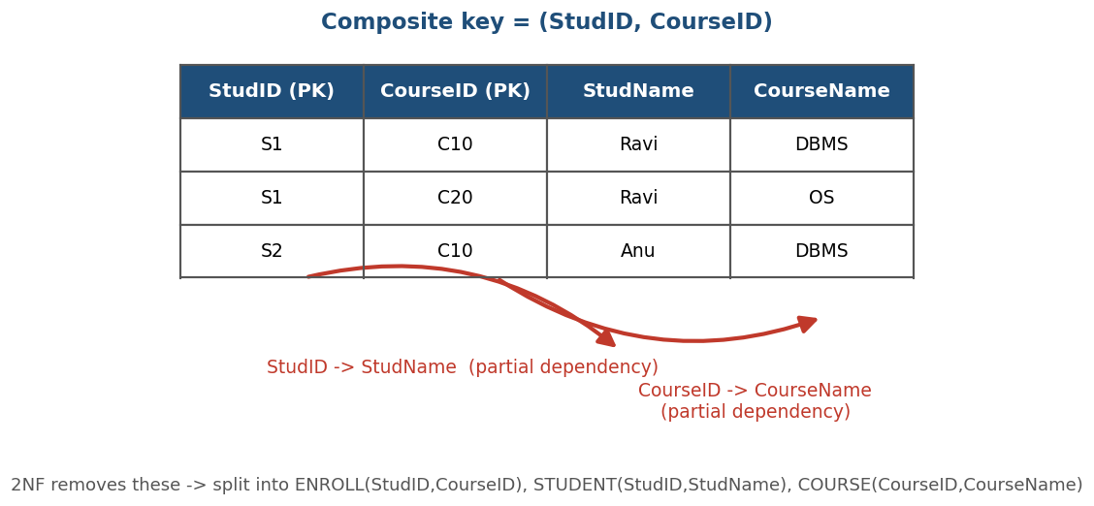
SQL Illustration:
-- Violates 2NF: StudName depends only on StudID (part of key)
CREATE TABLE Enroll_Bad (
StudID VARCHAR(10),
CourseID VARCHAR(10),
StudName VARCHAR(50),
CourseName VARCHAR(50),
PRIMARY KEY (StudID, CourseID)
);

-- Decomposed into 2NF
CREATE TABLE Student (StudID VARCHAR(10) PRIMARY KEY, StudName VARCHAR(50));
CREATE TABLE Course (CourseID VARCHAR(10) PRIMARY KEY, CourseName VARCHAR(50));
CREATE TABLE Enroll (StudID VARCHAR(10), CourseID VARCHAR(10),
PRIMARY KEY (StudID, CourseID));
Explanation:
2NF builds on 1NF by removing partial dependencies, i.e., every non-prime attribute must depend on the whole of a composite primary key, not just part of it.
Bloom's Level: BL2 – Understand Marks: 5

Question 3
Which normal form deals with multi-valued dependencies?
(a) 2NF
(b) 3NF
(c) BCNF
(d) 4NF ✓ Correct Answer
Concept:
A multi-valued dependency (MVD), written A ->> B, occurs when attribute A determines a SET of values of B, independently of other attributes in the relation. When two or more independent multi-valued facts are stored in the same table, it produces redundant combinations of rows. Fourth Normal Form (4NF) removes this by splitting the relation so each independent multi-valued fact lives in its own table.
Diagram:
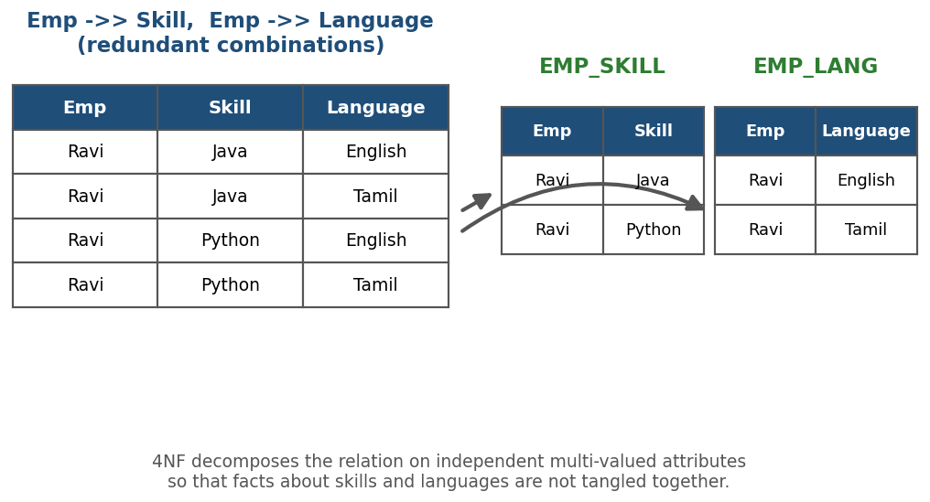
SQL Illustration:
-- Violates 4NF: Skill and Language are independent multivalued facts
CREATE TABLE Emp_Skill_Lang_Bad (
Emp VARCHAR(20),
Skill VARCHAR(20),
Language VARCHAR(20)
);

-- Decomposed into 4NF
CREATE TABLE Emp_Skill (Emp VARCHAR(20), Skill VARCHAR(20),
PRIMARY KEY (Emp, Skill));
CREATE TABLE Emp_Lang (Emp VARCHAR(20), Language VARCHAR(20),
PRIMARY KEY (Emp, Language));
Explanation:
Fourth Normal Form (4NF) specifically addresses multi-valued dependencies, ensuring a relation has no non-trivial multi-valued dependency other than a candidate key.
Bloom's Level: BL2 – Understand Marks: 5

Question 4
BCNF is a stricter version of:
(a) 1NF
(b) 2NF
(c) 3NF ✓ Correct Answer
(d) 4NF
Concept:
Boyce-Codd Normal Form (BCNF) is a stronger version of Third Normal Form (3NF). A relation is in 3NF if, for every FD X -> Y, either X is a superkey or Y is a prime attribute. BCNF removes the 'Y is a prime attribute' exception — it requires that X ALWAYS be a superkey. This makes BCNF stricter, eliminating some anomalies that can still slip through 3NF.
Diagram:
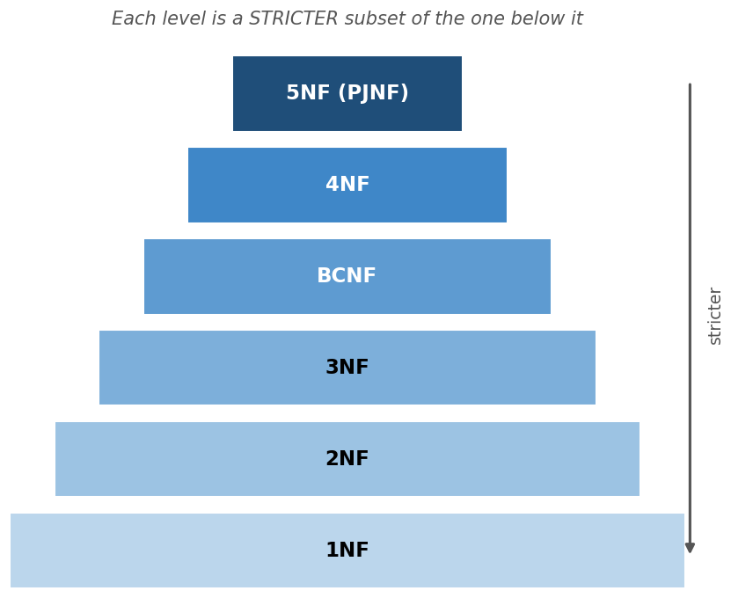
SQL Illustration:
-- 3NF but NOT BCNF example: Course determines Instructor,
-- but Course is not a superkey of (Student, Course)
CREATE TABLE StudentCourse (
Student VARCHAR(20),
Course VARCHAR(20),
Instructor VARCHAR(20), -- Course -> Instructor
PRIMARY KEY (Student, Course)
);

-- BCNF decomposition
CREATE TABLE Enrolls (Student VARCHAR(20), Course VARCHAR(20),
PRIMARY KEY (Student, Course));
CREATE TABLE Teaches (Course VARCHAR(20) PRIMARY KEY,
Instructor VARCHAR(20));
Explanation:
BCNF (Boyce-Codd Normal Form) is a stricter version of 3NF; it requires that for every functional dependency X→Y, X must be a superkey.
Bloom's Level: BL2 – Understand Marks: 5

Question 5
Functional dependency X → Y means:
(a) Y determines X
(b) X determines Y ✓ Correct Answer
(c) X and Y are unrelated
(d) Both determine each other
Concept:
A functional dependency (FD) X -> Y is a constraint between two sets of attributes in a relation: for every pair of tuples, if their X values are equal,heir Y values must also be equal. In other words, knowing the value of X is enough to determine the value of Y. FDs are the foundation for detecting redundancy and driving the normalization process (1NF through 5NF).
Diagram:
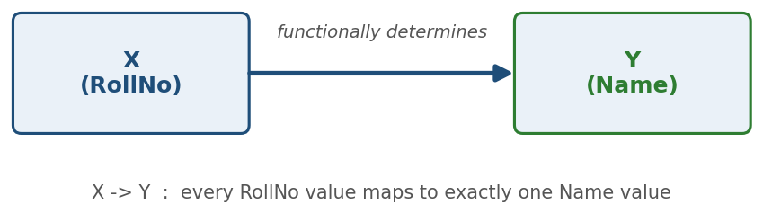
SQL Illustration:
-- RollNo -> Name (functional dependency)
SELECT DISTINCT RollNo, Name FROM Student ORDER BY RollNo;
-- For any given RollNo, only ONE Name should ever appear;
-- if two different names show up for the same RollNo,
-- the FD RollNo -> Name is violated.
Explanation:
In a functional dependency X → Y, the value of X uniquely determines the value of Y.
Bloom's Level: BL2 – Understand Marks: 5

Question 6
Which of the following anomaly is NOT associated with unnormalized relations?
(a) Insertion anomaly
(b) Deletion anomaly
(c) Update anomaly
(d) Retrieval anomaly ✓ Correct Answer
Concept:
Unnormalized or poorly normalized tables that mix unrelated facts together suffer from three classic anomalies: (1) Insertion anomaly — you cannot add certain facts without also having unrelated data on hand; (2) Deletion anomaly — deleting one fact accidentally destroys another, unrelated fact; (3) Update anomaly — the same fact is duplicated in many rows, so changing it means updating every copy consistently. 'Retrieval anomaly' is not a term used in relational theory — querying/reading data is not affected by normalization the way writes are.
Diagram:
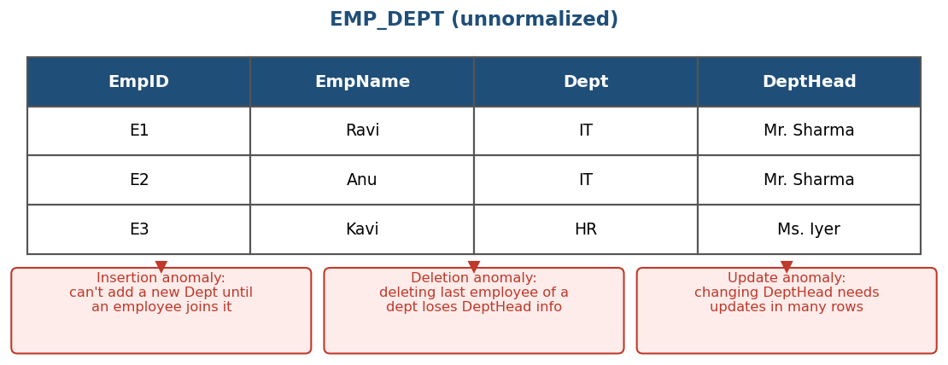
SQL Illustration:
-- Update anomaly example: changing the department head
-- requires updating EVERY row of that department
UPDATE Emp_Dept SET DeptHead = 'Mr. Kumar' WHERE Dept = 'IT';
-- If even one row is missed, the table becomes inconsistent.
Explanation:
Unnormalized relations suffer from insertion, deletion, and update anomalies. 'Retrieval anomaly' is not a recognized category of data anomaly.
Bloom's Level: BL2 – Understand Marks: 5

Question 7
A superkey is:
(a) A minimal set of attributes that uniquely identifies tuples
(b) Any set of attributes that uniquely identifies tuples ✓ Correct Answer
(c) An attribute that depends on a non-prime attribute
(d) A foreign key reference
Concept:
A superkey is any combination of one or more attributes whose values uniquely identify a tuple (row) in a relation. A superkey does NOT need to be minimal — adding extra attributes to a valid key still gives a (larger) superkey. A candidate key is a MINIMAL superkey (no attribute can be removed without losing uniqueness), and the primary key is the candidate key chosen by the designer to identify rows in the table.
Diagram:
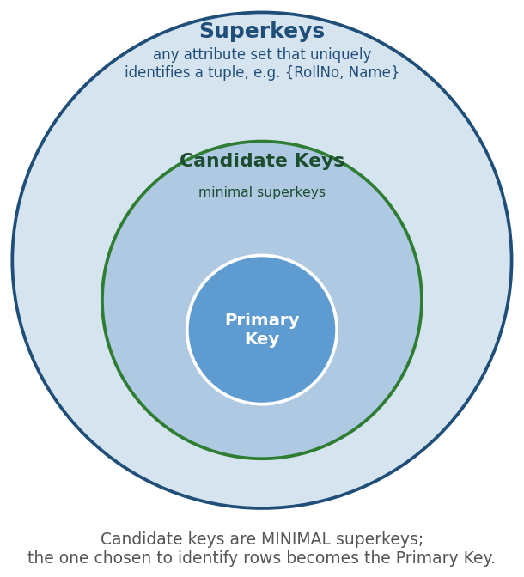
SQL Illustration:
-- If RollNo alone uniquely identifies a student:
-- Superkeys: {RollNo}, {RollNo, Name}, {RollNo, Name, DOB} ...
-- Candidate key: {RollNo} (minimal superkey)
-- Primary key: {RollNo} (chosen candidate key)
ALTER TABLE Student ADD PRIMARY KEY (RollNo);
Explanation:
A superkey is any set of one or more attributes that, taken collectively, uniquely identifies a tuple in a relation (it need not be minimal — that's a candidate key).
Bloom's Level: BL2 – Understand Marks: 5

Question 8
If R(A,B,C) has FD: A→B and B→C, then C is:
(a) Partially dependent on A
(b) Fully dependent on A
(c) Transitively dependent on A ✓ Correct Answer
(d) Independently determined
Concept:
A transitive dependency occurs when a non-key attribute depends on another non-key attribute, rather than depending directly on the primary key. Formally, if A -> B and B -> C hold (and B does not determine A), then by transitivity A -> C also holds, but only indirectly — through B. Third Normal Form (3NF) removes transitive dependencies by moving the transitively dependent attributes into a separate table.
Diagram:
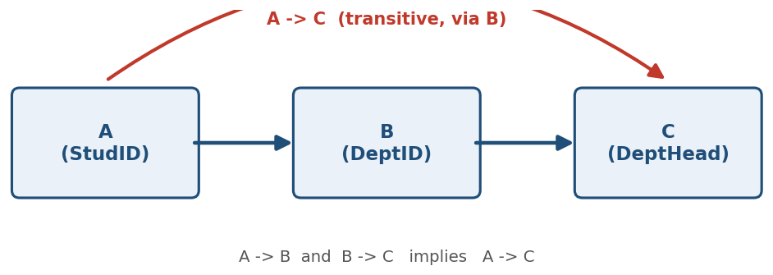
SQL Illustration:
-- StudID -> DeptID -> DeptHead (transitive dependency)
CREATE TABLE Student_Bad (
StudID VARCHAR(10) PRIMARY KEY,
DeptID VARCHAR(10), -- StudID -> DeptID
DeptHead VARCHAR(50) -- DeptID -> DeptHead (transitive)
);

-- Remove transitive dependency (3NF)
CREATE TABLE Student (StudID VARCHAR(10) PRIMARY KEY, DeptID VARCHAR(10));
CREATE TABLE Dept (DeptID VARCHAR(10) PRIMARY KEY, DeptHead VARCHAR(50));
Explanation:
Since A→B and B→C, by transitivity A→C holds indirectly through B, making C transitively dependent on A.
Bloom's Level: BL2 – Understand Marks: 5

Question 9
5NF is also known as:
(a) Domain-Key Normal Form
(b) Boyce-Codd Normal Form
(c) Project-Join Normal Form ✓ Correct Answer
(d) Element Normal Form
Concept:
Fifth Normal Form (5NF), also called Project-Join Normal Form (PJNF), deals with JOIN DEPENDENCIES. A relation satisfies 5NF if it cannot be decomposed into any smaller set of tables that, when joined back together (via natural join), would NOT reconstruct the original relation exactly. In short, 5NF removes redundancy caused by join dependencies that are not implied by candidate keys, and it is the final step of classical normalization.
Diagram:
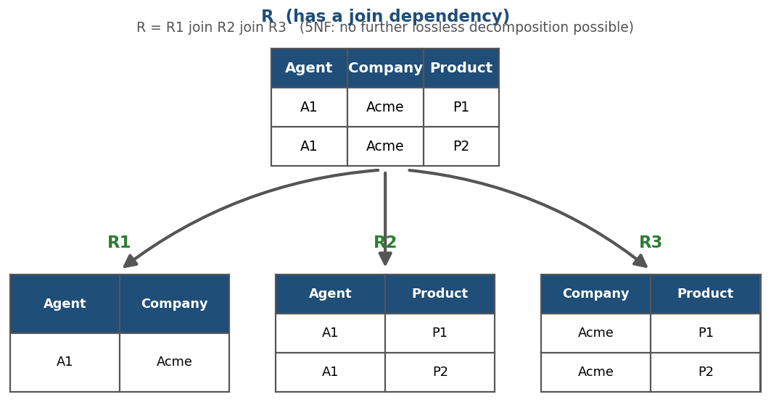
SQL Illustration:
-- R(Agent, Company, Product) has a join dependency
-- Decomposed into 5NF:
CREATE TABLE Agent_Company (Agent VARCHAR(10), Company VARCHAR(30));
CREATE TABLE Agent_Product (Agent VARCHAR(10), Product VARCHAR(30));
CREATE TABLE Company_Product(Company VARCHAR(30), Product VARCHAR(30));

-- Reconstruct original relation:
SELECT ac.Agent, ac.Company, cp.Product
FROM Agent_Company ac
JOIN Company_Product cp ON ac.Company = cp.Company
JOIN Agent_Product ap ON ap.Agent = ac.Agent AND ap.Product = cp.Product;
Explanation:
5NF is also called Project-Join Normal Form (PJNF); it deals with join dependencies and ensures a relation cannot be decomposed further without loss of information.
Bloom's Level: BL2 – Understand Marks: 5

Question 10
Lossless-join decomposition ensures:
(a) No data is lost during decomposition ✓ Correct Answer
(b) All FDs are preserved
(c) The relation is in BCNF
(d) No null values exist
Concept:
When a relation R is split into smaller relations R1 and R2 during normalization, the decomposition is called LOSSLESS-JOIN if joining R1 and R2 back together (natural join) reproduces exactly the original relation R — no rows lost, and no extra/spurious rows introduced. This is guaranteed when the common attribute(s) of R1 and R2 form a candidate key of at least one of them. A decomposition that fails this test is called 'lossy' and is unacceptable.
Diagram:
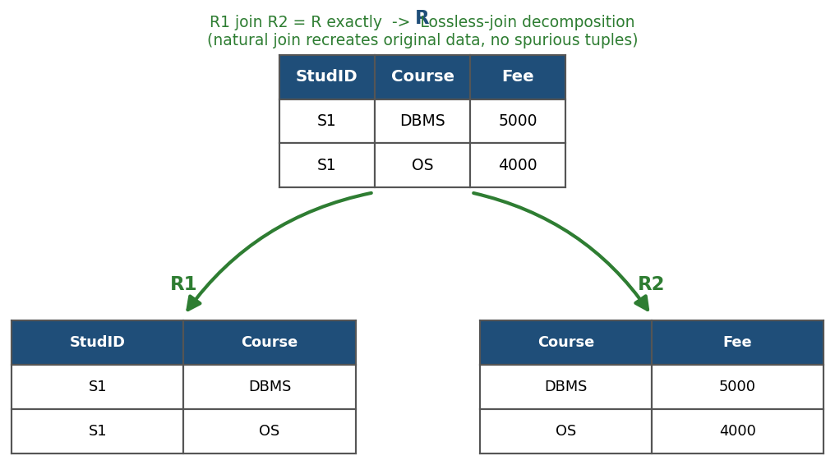
SQL Illustration:
-- R(StudID, Course, Fee) decomposed into R1, R2
CREATE TABLE R1 (StudID VARCHAR(10), Course VARCHAR(20));
CREATE TABLE R2 (Course VARCHAR(20) PRIMARY KEY, Fee INT);

-- Lossless-join test: rejoin and compare with original
SELECT R1.StudID, R1.Course, R2.Fee
FROM R1 JOIN R2 ON R1.Course = R2.Course;
-- Result should exactly match the original R (no rows gained/lost)
Explanation:
A lossless-join decomposition guarantees that when the decomposed relations are joined back together, the original relation is exactly reconstructed with no spurious or missing tuples.
Bloom's Level: BL2 – Understand Marks: 5

